***BSEF17A503***

***Maryam Shahzad***

***OS Lab 01***

**Question no 1:**

1: who command will use to see the name of current user.

2: First we will move to tmp directory and then make a file by touch command.

3: We’ll check the type. Let first write some type of data e.g. ASCII and then check the file type by file command.

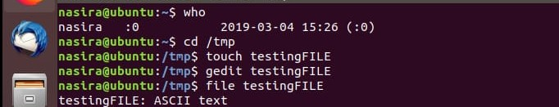

4: There are two ways to remove a directory. Rmdir to remove an empty directory and ram to remove a filled directory.

5: To go back to home directory we will use../.

6: First we make a file named as tryit& and then rename it by mv command.

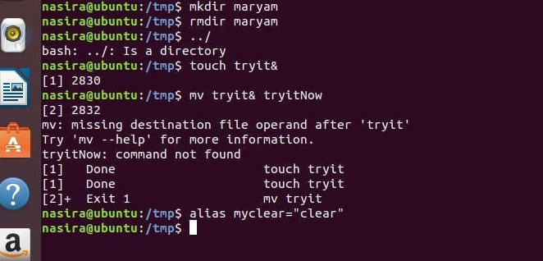

7: we will make alias of clear command by just using alias command.

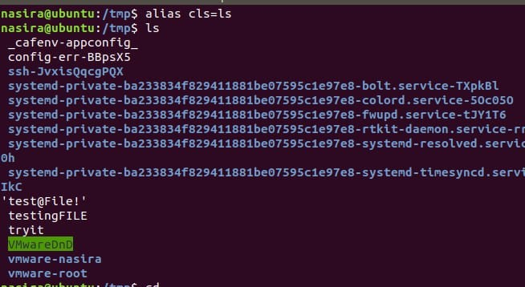

8: Output of the given command are shown in figures as follows:

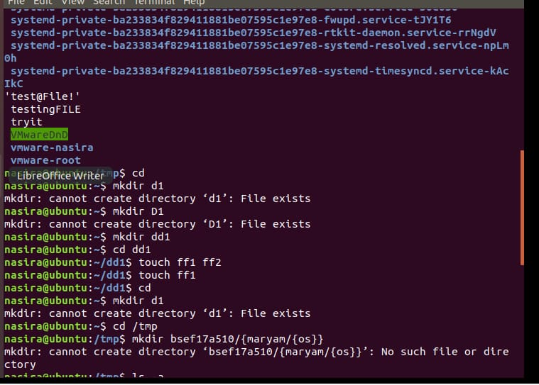

***Question no 2:***

1: To make a directory we will use mkdir command.

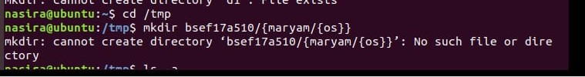

2: To show the details of hidden files we will use ls –a.

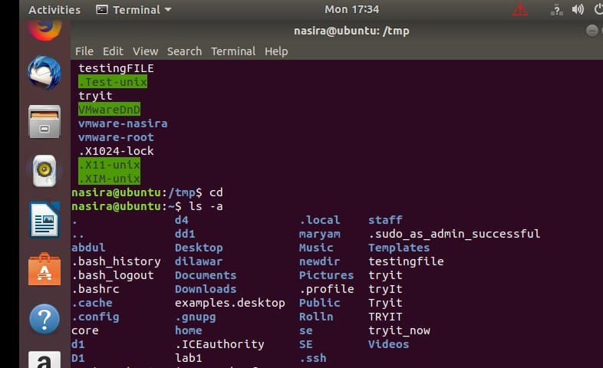

3: To remove the file that we make in previous questions.

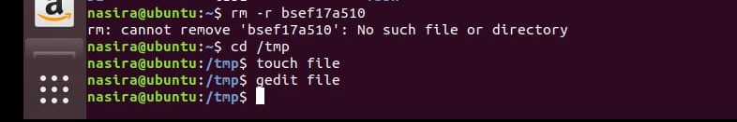

4: First make a file and then writr in this file using gedit command and then show the written lines by cat command.

5: We will rename this file by using mv command.

6: Display the last two lines of the file by tail command.

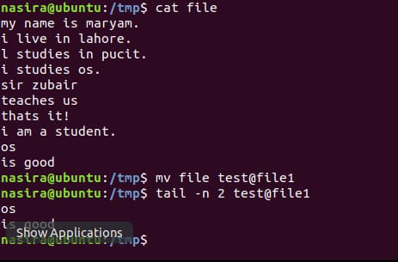

7: As I used the rmdir command in previous questions so I will make the alias of rmdir command.

8: We will use man command to see the shell commands.

9: to find whwther the command is a shell command we will use type command.

10: we can use rmdir –r to remove a directory instead of rmdir.

